Frontier Scripts

**Customer Search (Green Screen OE72)**

When entering a sales order, if you do not know the customer number click the magnifying glass icon next to the text box to display the Search for Customer ID page. An asterisk indicates criteria that support the use of wildcards. Wildcards may be used for the search criteria (except the State and Sales order number). The use of an asterisk as a wildcard is limited to the end of a value (**not to be used at the beginning or in the middle of the value**).

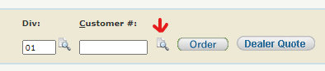

Example of searching for Customer with a wildcard (*)

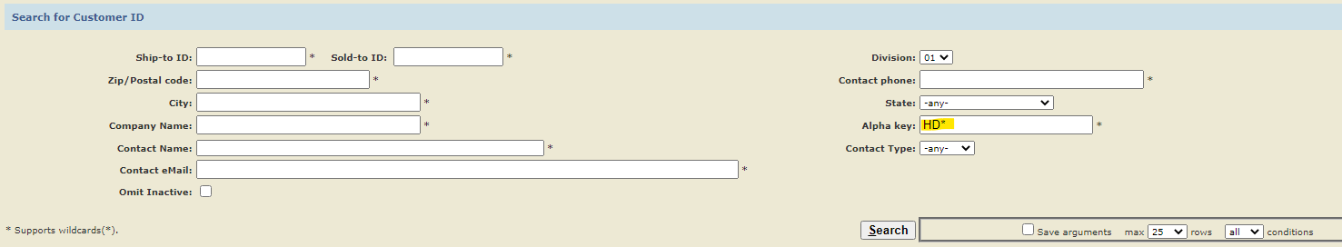

Customers that meet the selected criteria are listed in ascending sequence by customer number. You may sort the list by clicking any column heading; click once to sort in ascending sequence and again to sort in descending sequence.

Frontier Scripts

**Search for Orders (iSales Inquiry) (Green Screen OE76)**

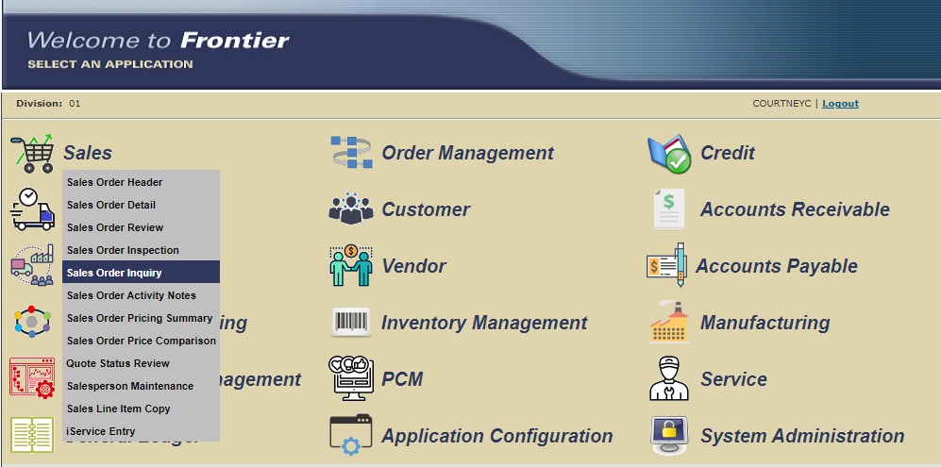

Hover over Sales and choose the Sales Order Inquiry to monitor sales orders and all information associated with it. This is where you will look for shipping or tracking information or to look at information for already entered PO#s.

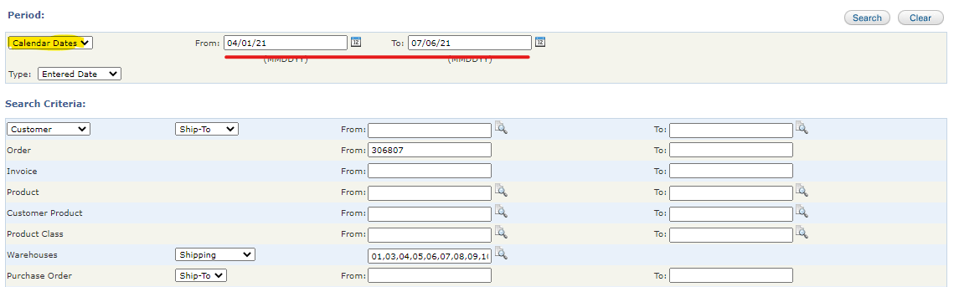

*** extend “Calendar Dates” to include multiple weeks/months unless you know exact order date of PO you are looking up. ***

Frontier Scripts

**Search for Orders Continued (iSales Inquiry) (Green Screen OE76)**

Ways to search under Sales Order Inquiry:

* Customer: Customer Number
* Order: Our Sales Order Number
* Purchase Order: Customer’s PO Number
* User: Entry Tech Name (first name, last initial)

Once you have clicked “Search”, scroll down to Shipping Information. It will then show any tracking information that has been put into the system. 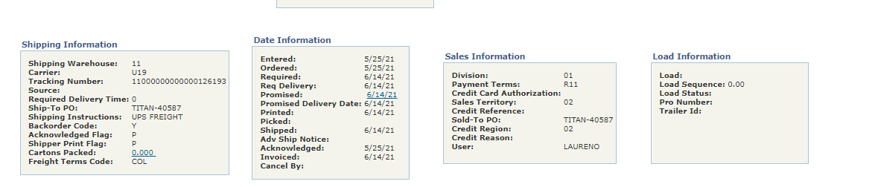

Frontier Scripts

**Product Inventory (Green Screen IV26)**

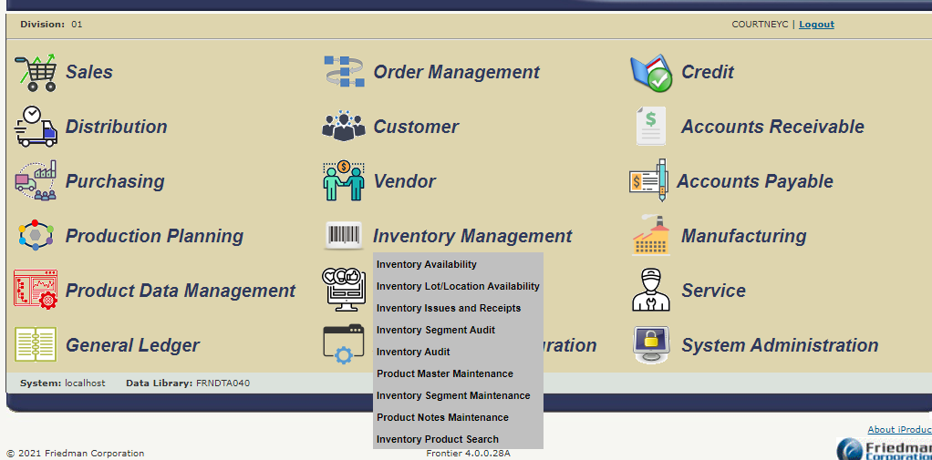

To find on hand inventory of a product, select Inventory Availability from the Inventory Management tab. Type the Part Number into Product line or click on the magnifying glass for a list of products and their part numbers.

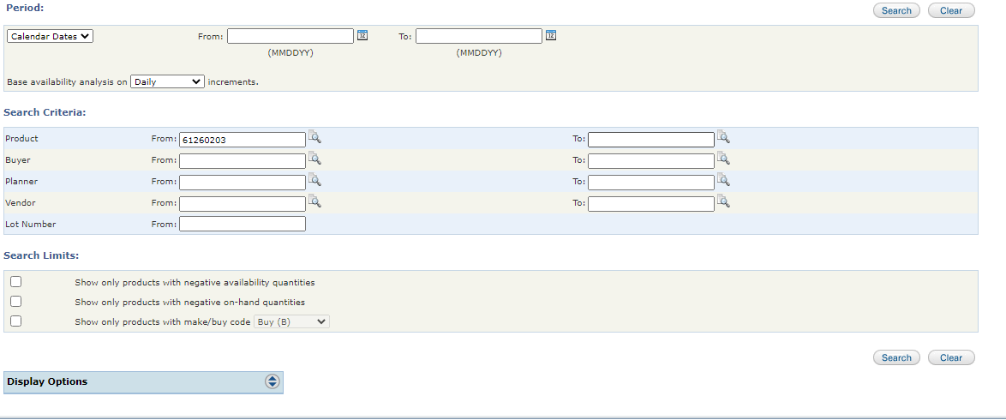

Once you click Search, it will break down availability by warehouse (first column) so you will see how many each warehouse has on hand as well as how many are on order.

Frontier Scripts

**Product Master (Green Screen PM72)**

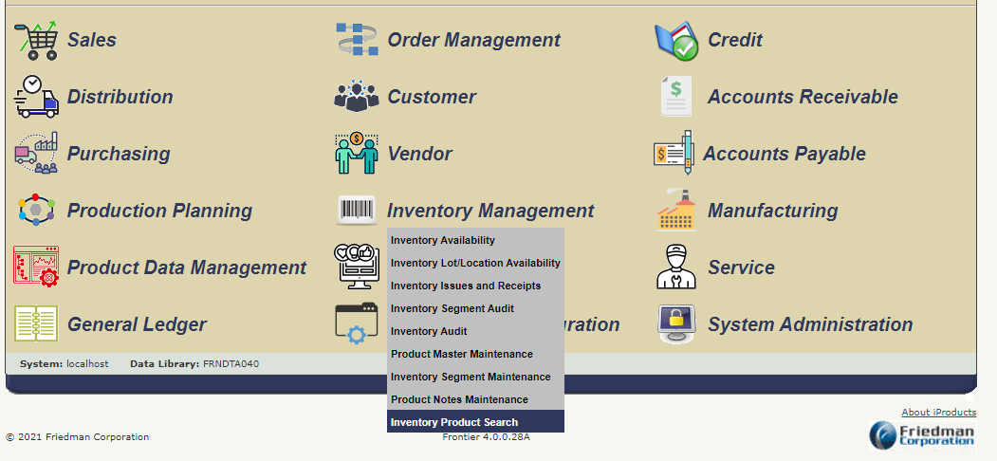

Use the Inventory Product Search under Inventory Management to type in a description that might help you find a part; IE: t-stk, paint, etc. In the first drop-down list select Description as shown in the picture below.

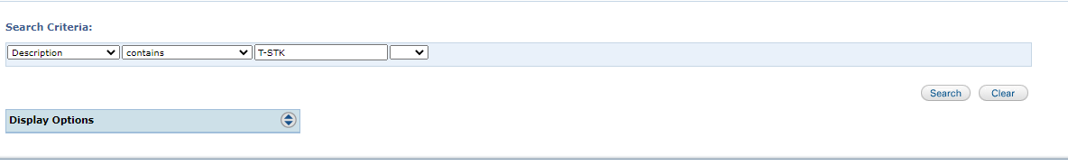

Click Search after entering your description to generate list of products that meet the criteria.